**Number Puzzles**

**Questions**

Q1. What number comes inside the circle?

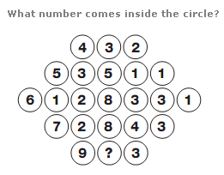

|  |  |
| --- | --- |
| A | 6 |
| B | 8 |
| C | 9 |
| D | 10 |

Q2. Which number replaces the question mark?

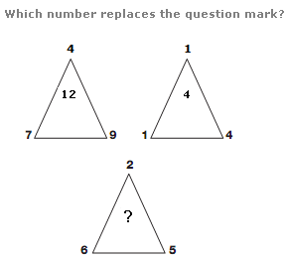

|  |  |
| --- | --- |
| A | 2 |
| B | 4 |
| C | 9 |
| D | 8 |

Q3. Which number completes the puzzle?

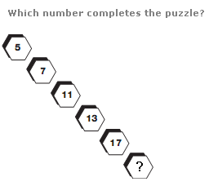

|  |  |
| --- | --- |
| A | 5 |
| B | 2 |
| C | 10 |
| D | 19 |

Q4. Which number replaces the question mark?

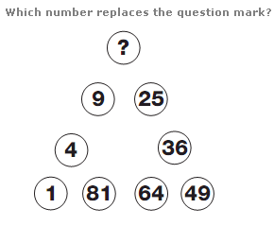

|  |  |
| --- | --- |
| A | 12 |
| B | 16 |
| C | 13 |
| D | 7 |

Q5. Which number replaces the question mark?

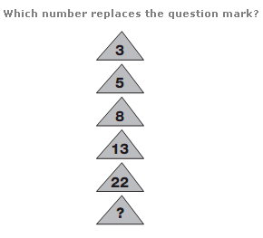

|  |  |
| --- | --- |
| A | 4 |
| B | 12 |
| C | 39 |
| D | 30 |

Q6.which letter replaces the question mark?

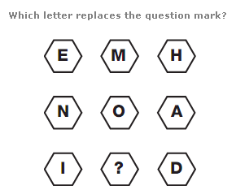

|  |  |
| --- | --- |
| A | M |
| B | V |
| C | R |
| D | E |

Q7. Which letter replaces the question mark?

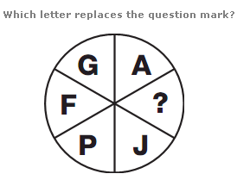

|  |  |
| --- | --- |
| A | S |
| B | P |
| C | D |
| D | K |

Q8. What is missing in the last grid?

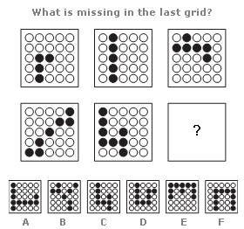

|  |  |
| --- | --- |
| A | A |
| B | D |
| C | E |
| D | F |

Q9. Which letter replaces the question mark?

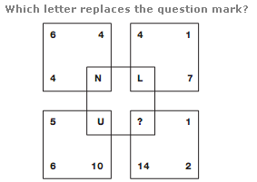

|  |  |
| --- | --- |
| A | Q |
| B | P |
| C | S |
| D | N |

Q10. Which number replaces the question mark?

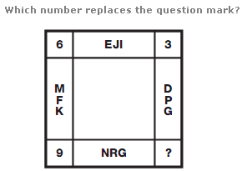

|  |  |
| --- | --- |
| A | 13 |
| B | 9 |
| C | 12 |
| D | 10 |

Q11. Which letter replaces the question mark?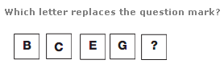

|  |  |
| --- | --- |
| A | O |
| B | K |
| C | I |
| D | J |

Q12. Which letter replaces the question mark?

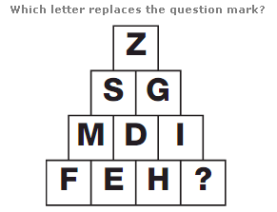

|  |  |
| --- | --- |
| A | Z |
| B | J |
| C | G |
| D | I |

Q13. Which letter replaces the question mark?

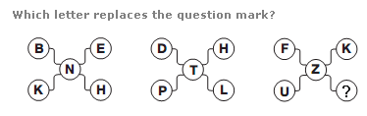

|  |  |
| --- | --- |
| A | P |
| B | Z |
| C | Q |
| D | T |

Q14. Which number replaces the question mark?

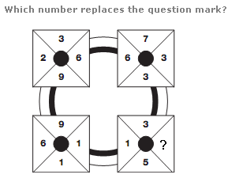

|  |  |
| --- | --- |
| A | 13 |
| B | 9 |
| C | 12 |
| D | 10 |

Q15. Which number replaces the question mark?

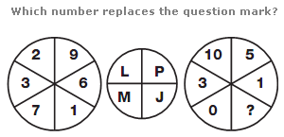

|  |  |
| --- | --- |
| A | 9 |
| B | 4 |
| C | 2 |
| D | 10 |

Q16. Which letter replaces the question mark?

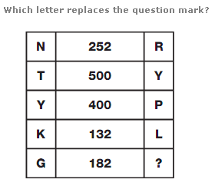

|  |  |
| --- | --- |
| A | G |
| B | A |
| C | Z |
| D | D |

Q17. Which letter replaces the question mark?

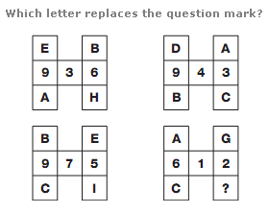

|  |  |
| --- | --- |
| A | F |
| B | U |
| C | I |
| D | E |

Q18. Which letter replaces the question mark?

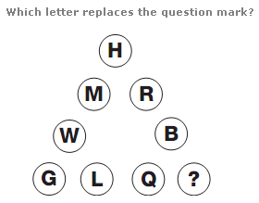

|  |  |
| --- | --- |
| A | U |
| B | P |
| C | N |
| D | V |

Q19. Which number replaces the question mark?

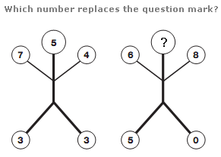

|  |  |
| --- | --- |
| A | 10 |
| B | 2 |
| C | 9 |
| D | 5 |

Q20. Which number replaces the question mark?

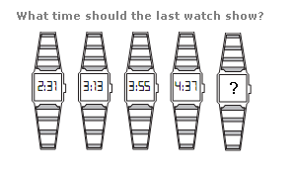

|  |  |
| --- | --- |
| A | 5:45 |
| B | 5:10 |
| C | 5:20 |
| D | 5:19 |

ANSWER SHEET

**Q.1.** 6

Looking at the diagram in rows, the central circle equals half the sum of the numbers in the other circles to the left and right of the centre.

**Q.2.** 9

The number at the centre of each triangle equals the sum of the lower two numbers minus the top number.

**Q.3.**  19

As you move diagonally down, numbers follow the sequence of Prime Numbers.

**Q.4.** 16

Starting bottom left and moving clockwise around the triangle, numbers follow the sequence of Square Numbers.

**Q.5.** 39

Working from top to bottom, double each number and subtract 1, then 2, then 3 etc.

**Q.6.** M

Working in rows, add together the numerical values of the left and right hand letters to give the numerical value of the central letter.

**Q.7.** K

The numerical values of the letters in opposite segments of the circle always add up to 17.

**Q.8.** D

The number of black dots in each grid increases by 1 each time, starting with the top left grid and working to the right, top row then bottom row.

**Q.9.** Q

Adding the three numbers in each square together gives the numerical value of the letter at the centre of each square.

**Q.10.** 12

The value at each corner of the diagram equals the difference between the sums of the numerical values of the letters in the boxes adjacent to the corner.

**Q.11.**  K

As you move down, the numerical value of the letters follows the sequence of Prime Numbers.

**Q.12.** G

The numerical values of the letters in each row add up to 26 each time.

**Q.13.**  P

In each diagram, starting on the top left and moving clockwise in a spiral towards the centre, letters increase in value by 3 for the left hand diagram, 4 for the middle, and 5 for the right hand diagram.

**Q.14.**  9

Starting with the top left square, and moving clockwise around the other 3, the sum of the digits in each square follows the sequence 20, 19, 18, 17.

**Q.15.**  4

Split the left and right hand circles in half vertically. The letter with the numerical value of the sum of the digits in the left half of the left hand circle is placed in the top left segment of the central circle, and the letter with the numerical value of the sum of the digits in the right half of the left hand circle is placed in the top right segment of the central circle. Repeat this formula for the 2 halves of the right hand circle, putting the resulting letters in the lower segments of the central circle.

**Q.16.**  Z

In each row, multiply the numerical values of the left and right hand letters, putting the result in the centre.

**Q.17.**  F

In each diagram, convert each letter to its numerical value, and read the top and bottom pairs of letters as complete 2 digit values. Multiply these values together to give the 3 digit result written in the centre spaces.

**Q.18.** V.

Start at the top, and work through the triangle in horizontal rows, from top to bottom, left to right. Letters move through the alphabet 5 letters at a time.

**Q.19.** 2

In each diagram, multiply the numbers shown on the arms together and add the number at the very top to give a 2 digit result, written in the lower 2 spaces.

**Q.20.**  5:19

Starting with the watch on the left, add 42 minutes to the time shown to give the time on the next watch to the right.